# **2 Methods For Loading Data Into A Table**

(always replace *brendahmcfarland* in examples with your username)

1. **Check to see if you have your own database**, **the name will be the same as your logon id.**

Type **show databases**

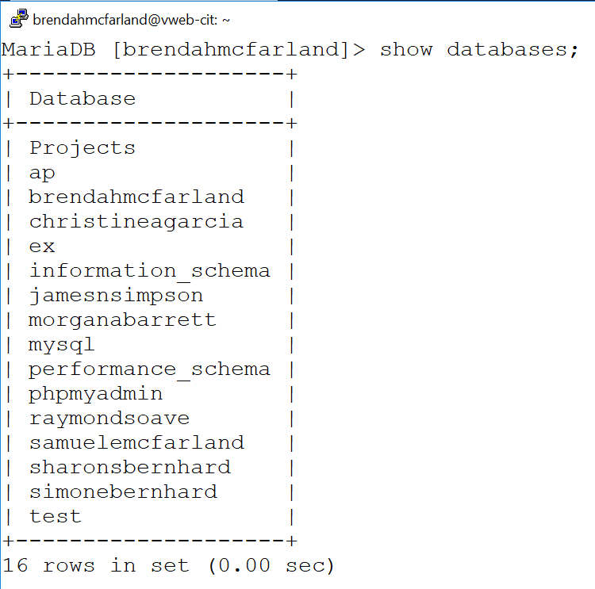

1. **If you do not have a database**, create your own database (named like your username).

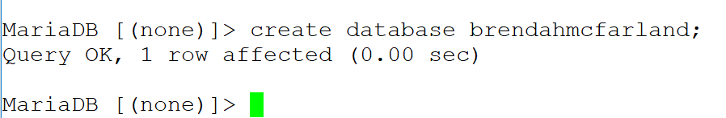

1. Check again to make sure that your own database is there.
2. **Make your database the active database.**

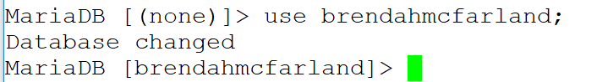

1. Check to see if you have a **table named products**.

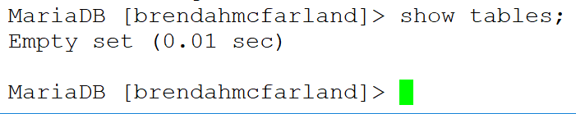

1. **Using notepad++**, create a batch sql file called **create_products_table.sql** If you save it as a .sql file first, then keywords will show in color.

You want to drop the existing table if there is one and create a new empty table.

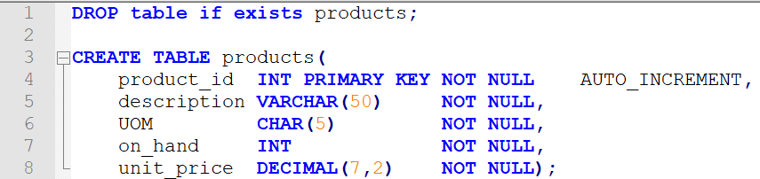

1. **Use** **FileZilla** (or some other method of your choosing) **to move the file from your computer to your home directory on the server.** Remember, when you connect to the server you are automatically in your home directory.

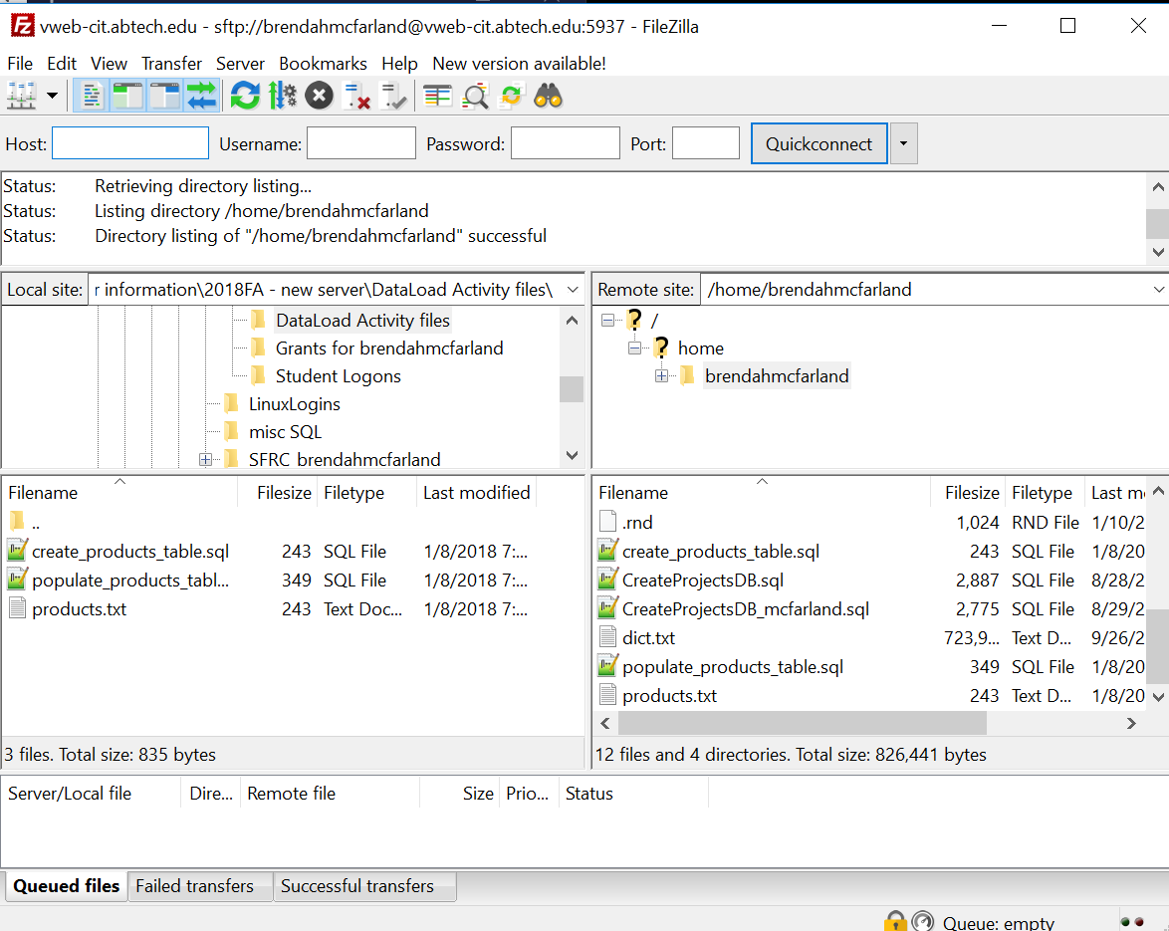

1. **Execute the file** **by using the source command**. You do not have to “path” the name since you logged on to MySQL from your home directory, then it is automatically pointing there.

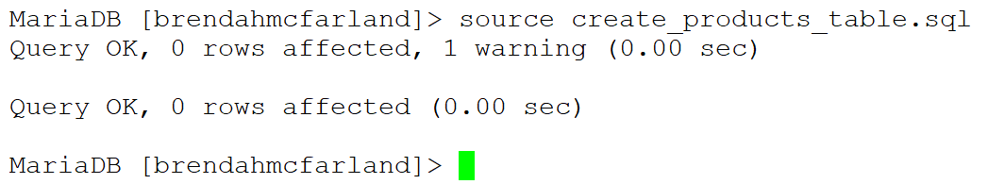

1. **Verify that the table is there** and **that it is empty.**

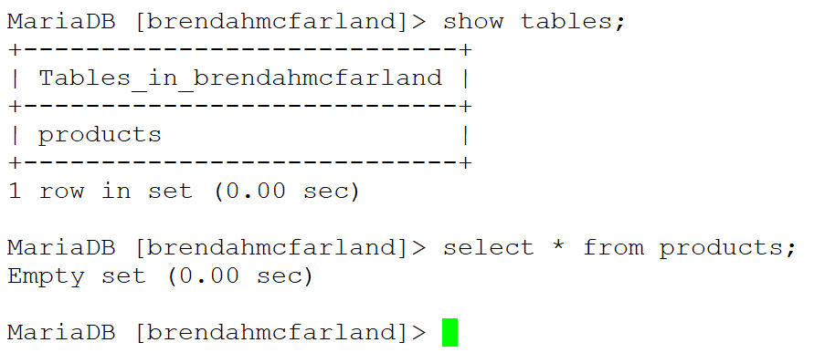

1. Now let’s create some data to put into the table … create a new file in your editor (notepad++) called **populate_products_table.sql** (**do not use tabs**).

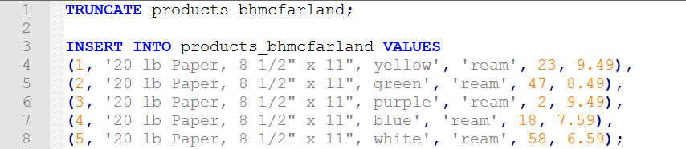

1. **Use FileZilla** (or some other method of your choosing) **to move the file to your home directory on the server.**
2. **Execute the file by using the source command**. This will insert the 5 rows in your file into the table you created in step 5 (product).

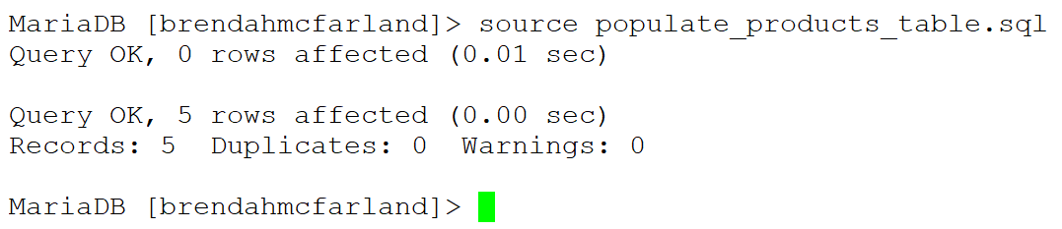

1. **Verify that the table is populated now.**

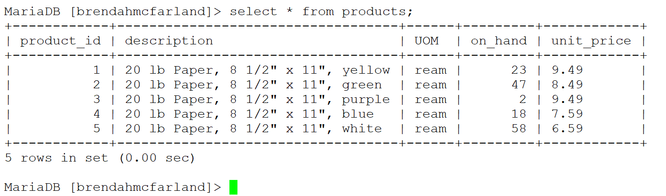

1. **Take a screenshot of the data in your products table. Open a blank Word document and paste the screenshot into the document. Save this screenshot as [initials]Activity3_dataload.docx (Leave this document open.)**
2. **Truncate the data from the products table** and **then verify that it is an empty table**.

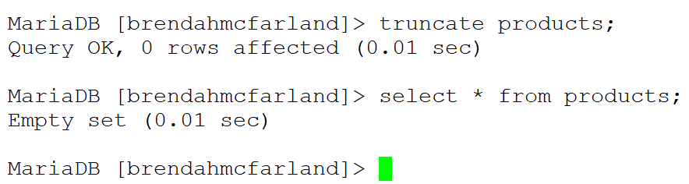

1. Now let’s create some data to put into table using the command line … create a new file in your editor called **products.txt**. **Use a single tab between fields and enter at the end of the row. Do not leave a blank row(s) at the end.**

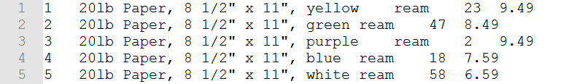

1. **Use FileZilla** (or method of your choosing) **to move the file to your home directory on the server.**
2. Now let’s **load the data from this txt file into the products table.**

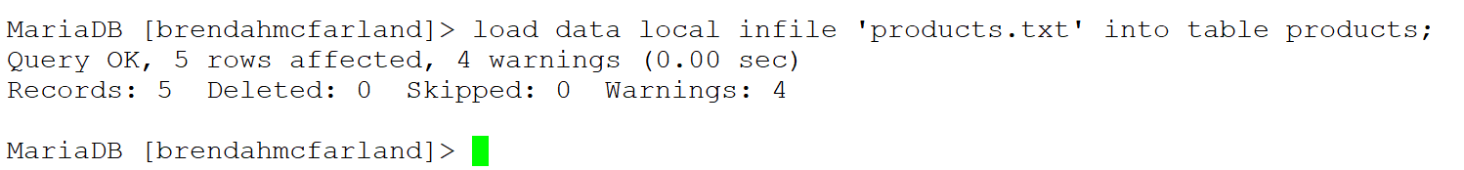

**Verify that your data is loaded**:

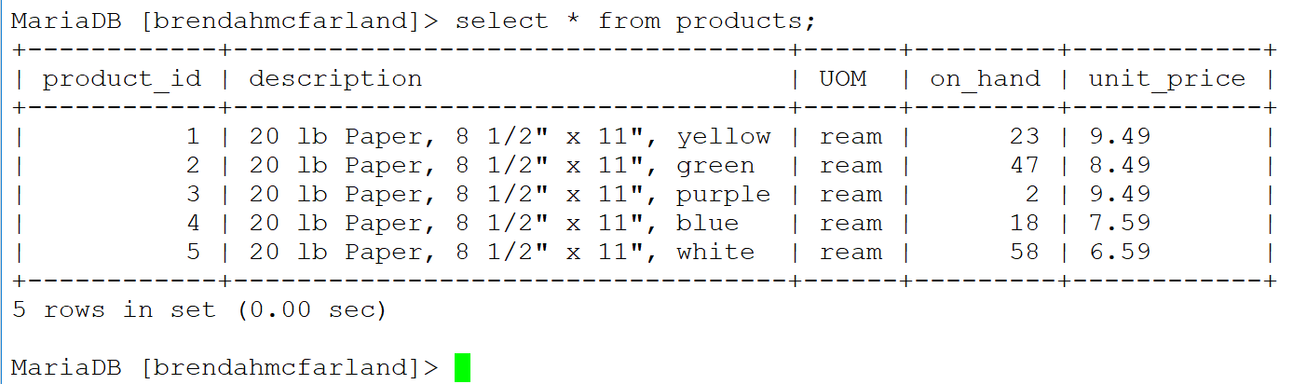

1. **Take a screenshot of the data in your products table**. **Paste this screenshot into the open [initials]Activity3_dataload.docx document.**

20. **Submit** your **[initials]Activity3_dataload.docx** file **in Moodle.**